**Chi -Square Test – Worked Example**

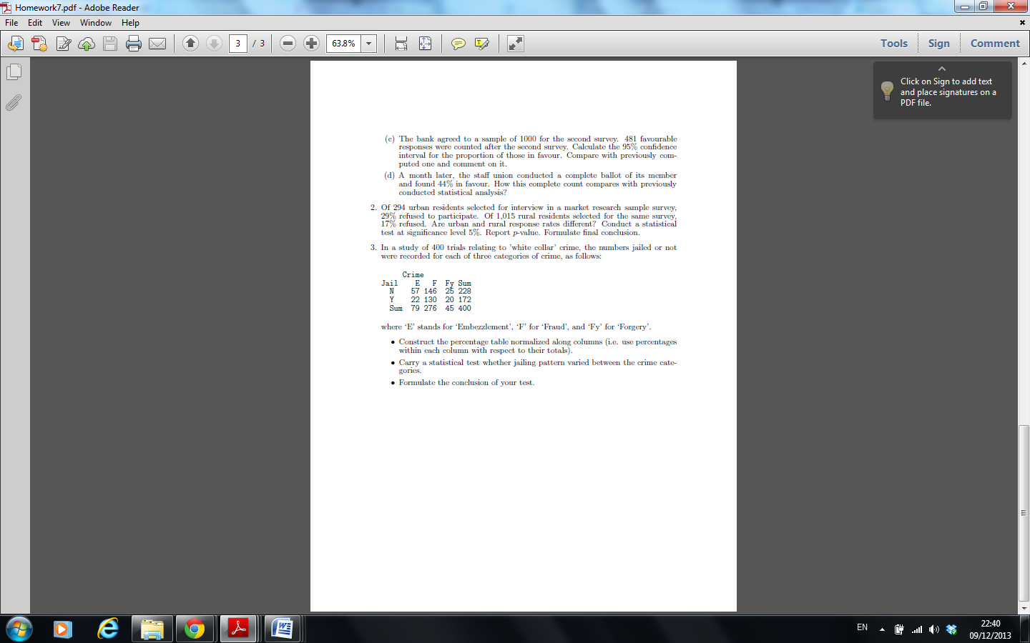

**Solution:**

• The percentage table normalized along columns is obtained by expressing the percentage of each entry with respect the column total and is presented below:

